# Fixed Document

This is a fixed document. It contains only a little text and the following table:

|  |  |
| --- | --- |
| Control | Purpose |
| DocumentViewer | Displays FixedDocument content such as XPS (XML Paper Specification) files. |
| FlowDocumentPageViewer | Displays a FlowDocument in page viewing mode. |
| FlowDocumentReader | Displays a FlowDocument in Page, Scroll, or TwoPage mode. |
| FlowDocumentScrollViewer | Displays a FlowDocument in Scroll mode. |

**Table 1. Document Viewing Controls**

Figure 1 shows some flowers. Notice how the text flows around the figure. Also notice how Word attaches a caption to the figure.

Here’s a simple bulleted list. WPF documents can contain a wide variety of objects such as:

* Paragraphs.
* Tables.

Figure . Colorado flowers.

* Lists.
* Floaters.
* Figures.
* User interface elements such as Buttons and TextBoxes.
* Three-dimensional objects.

The following page shows some information about one of my recent books. I’m including it mostly to fill space.

**Beginning Database Design Solutions**

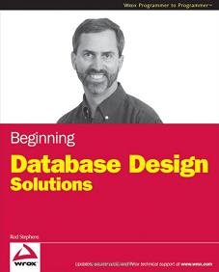Rod Stephens  
$44.99, 552 pages, 2008  
Wrox  
ISBN 978-0-470-38549-4  
Paperback

**From the back cover:**

The database is the foundation on which all other development rests. Make your foundation solid!

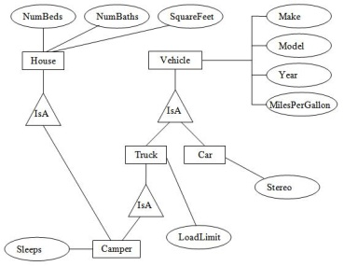This concise introduction teaches database design concepts, methods, and techniques of high-quality database design. You'll explore creating an initial logical design and refining it into a superior database that meets users' requirements. Plus, you'll see how to implement the design using specific types of database platforms and build databases using SQL scripts. Each chapter begins with a list of topics that will be covered, closes with a summary that provides the key points described in the chapter, and includes a list of review questions and a series of helpful exercises.

This book does not require any previous programming or database experience. You can follow most of the material with a simple pencil (or a pen if you're particularly confident in your work) and paper.

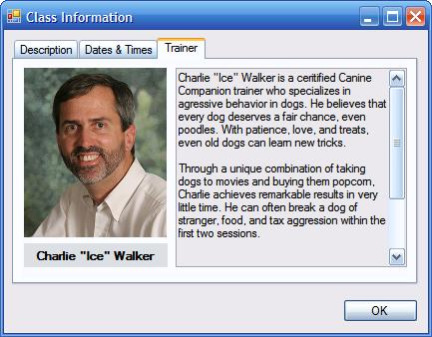A few chapters explain how to use Access and MySQL databases so you'll need those products to get the most out of those chapters. (Note that MySQL is FREE so this provides a nice introduction to a powerful database tool without a lot of expense.)

Learn more about this book at the [VB Helper](http://www.vb-helper.com/db_design.htm) or [Amazon](http://www.amazon.com/exec/obidos/ASIN/0470385499/vbhelper) web sites.